Experiment: 9
Aim:
To design and implement a Theme Settings web page using HTML, CSS, and JavaScript that allows users to switch between Light and Dark themes, save the selected theme using localStorage, load the saved preference, and clear the stored theme settings.
Software/Tools Required: VSC, HTML, CSS, JavaScript
Case Study program code:
index.html:
<!DOCTYPE html>
<html lang="en">
<head>
<meta charset="UTF-8">
<meta name="viewport" content="width=device-width, initial-scale=1.0">

<title>Theme Settings</title>

<link rel="stylesheet" href="style.css">
</head>

<body>

<div class="theme-card">

<h1>Theme Settings</h1>

<p>Select your preferred theme:</p>

<select id="themeSelect">
<option value="light">Light</option>
<option value="dark">Dark</option>
</select>

<div class="buttons">

<button onclick="saveTheme()">
Save using localStorage
</button>

<button onclick="loadTheme()">
Load using localStorage
</button>

</div>

<button class="clear-btn" onclick="clearPreferences()">
Clear Preferences
</button>

<p id="status">Theme preferences cleared.</p>

</div>

<script src="script.js"></script>

</body>
</html>
Script.js:
const themeSelect = document.getElementById("themeSelect");
const status = document.getElementById("status");

// Apply selected theme

function applyTheme(theme) {

if (theme === "dark") {

document.body.classList.add("dark");

} else {

document.body.classList.remove("dark");

}

themeSelect.value = theme;
}

// Save theme

function saveTheme() {

const selectedTheme = themeSelect.value;

localStorage.setItem("theme", selectedTheme);

applyTheme(selectedTheme);

status.textContent =
"Theme saved successfully.";
}

// Load theme

function loadTheme() {

const savedTheme = localStorage.getItem("theme");

if (savedTheme) {

applyTheme(savedTheme);

status.textContent =
"Theme loaded from localStorage.";

} else {

status.textContent =
"No saved theme found.";
}
}

// Clear preference

function clearPreferences() {

localStorage.removeItem("theme");

applySystemTheme();

status.textContent =
"Theme preferences cleared.";
}

// Check system theme

function applySystemTheme() {

const systemDark =
window.matchMedia("(prefers-color-scheme: dark)").matches;

if (systemDark) {

applyTheme("dark");

} else {

applyTheme("light");
}
}

// When page loads

window.onload = function () {

const savedTheme = localStorage.getItem("theme");

if (savedTheme) {

applyTheme(savedTheme);

status.textContent =
"Saved theme loaded automatically.";

} else {

applySystemTheme();

status.textContent =
"Using system theme preference.";
}
};

Style.css:
/* Light Theme */

:root {
--bg-color: #f5f5f5;
--card-color: white;
--text-color: #222;
--secondary-text: #555;
--button-bg: #eeeeee;
--button-text: #222;
--border-color: #dddddd;
}

/* Dark Theme */

body.dark {
--bg-color: #181818;
--card-color: #242424;
--text-color: white;
--secondary-text: #bbbbbb;
--button-bg: #383838;
--button-text: white;
--border-color: #444444;
}

/* General */

* {
box-sizing: border-box;
}

body {
margin: 0;
min-height: 100vh;

display: flex;
justify-content: center;
align-items: center;

background-color: var(--bg-color);
color: var(--text-color);

font-family: Arial, sans-serif;

transition: 0.3s;
}

/* Card */

.theme-card {
width: 650px;

padding: 55px;

background-color: var(--card-color);

border: 1px solid var(--border-color);
border-radius: 15px;

text-align: center;

box-shadow: 0 5px 20px rgba(0, 0, 0, 0.12);
}

/* Heading */

h1 {
margin-bottom: 15px;
font-size: 36px;
}

p {
color: var(--secondary-text);
font-size: 18px;
}

/* Dropdown */

select {
margin: 20px 0;

padding: 10px;

font-size: 16px;

border: 1px solid var(--border-color);
border-radius: 6px;

background-color: var(--card-color);
color: var(--text-color);

cursor: pointer;
}

/* Buttons */

.buttons {
display: flex;

justify-content: center;

gap: 20px;

margin-top: 15px;
}

button {
padding: 14px 22px;

border: none;

border-radius: 6px;

background-color: var(--button-bg);
color: var(--button-text);

font-size: 15px;

cursor: pointer;

transition: 0.2s;
}

button:hover {
opacity: 0.8;
transform: translateY(-2px);
}

.clear-btn {
margin-top: 20px;
}

Output:
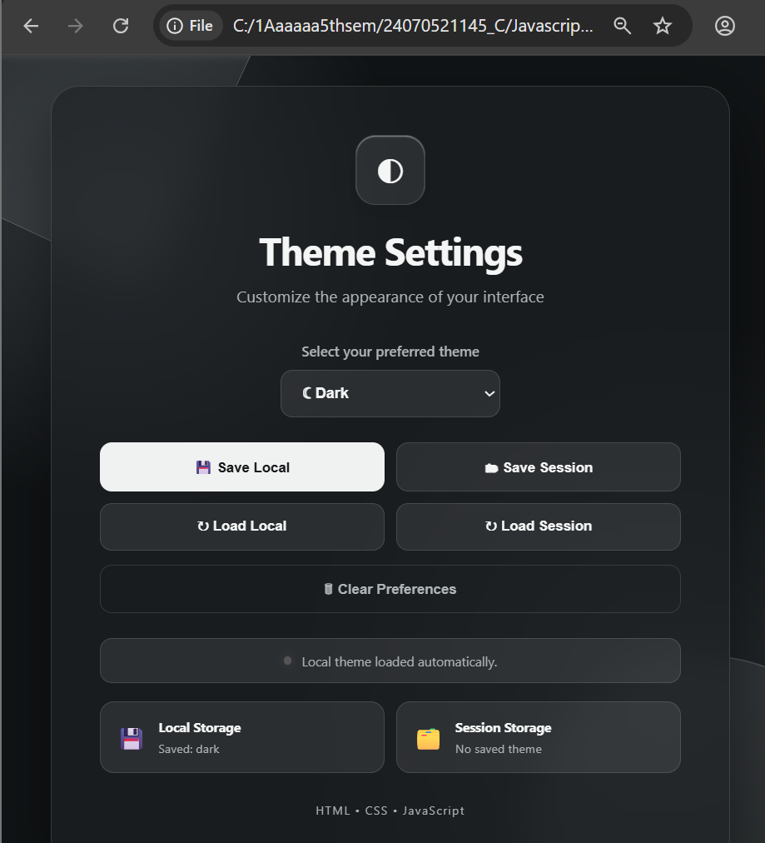

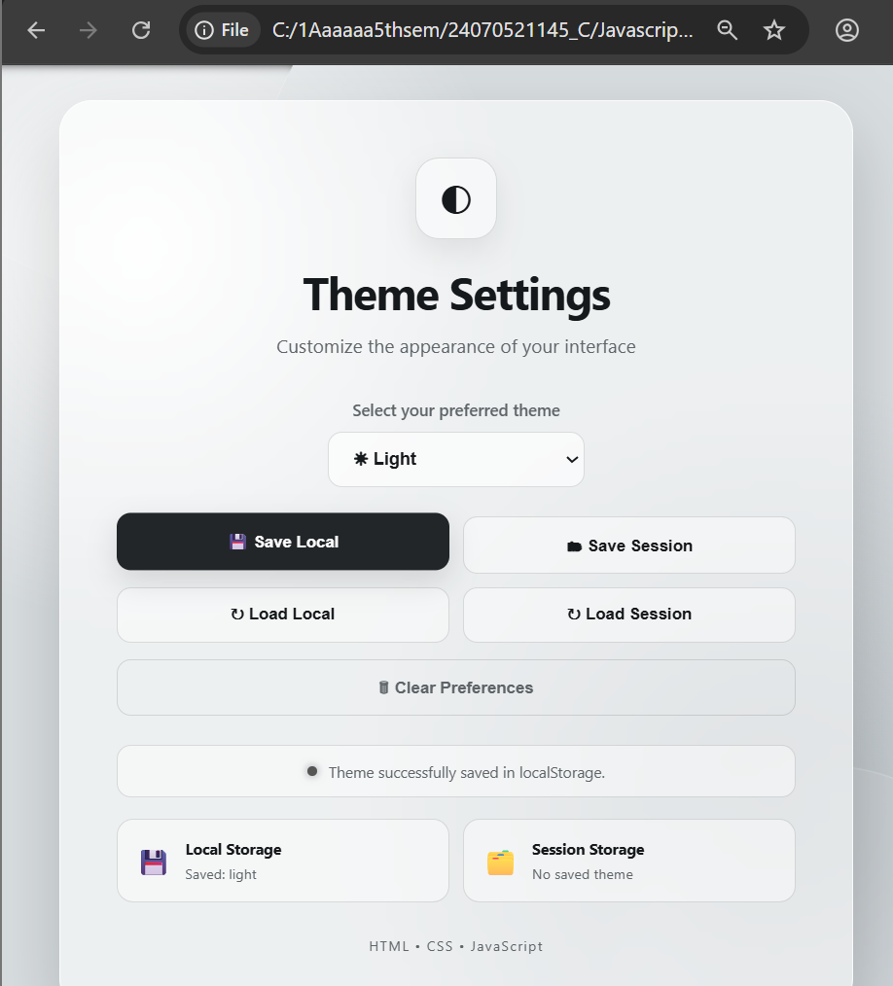
Result: The Theme Settings webpage was successfully implemented using HTML, CSS, and JavaScript. The user can switch between Light and Dark themes, save the selected theme in localStorage, load the saved preference, and clear the stored theme. The selected theme also remains available after refreshing the webpage, demonstrating successful client-side preference storage.

